NAME:

M Nauman Anwar

# Code Documentation

## 1) remove_special_chars function

This function removes all special characters (like , ? ! ;) from a string.

It only keeps alphabets, numbers, and spaces.

It uses regular expressions (re.sub) to replace unwanted characters with an empty string.

For example, 'Kuch, Bhi!' becomes 'Kuch Bhi'.



## 2) Bubble Sort (character sorting with ASCII values)

This part takes text and breaks it into characters.

It sorts them using Bubble Sort by comparing ASCII values (ord).

ord() gives the number of each character, and chr() converts back to character.

At the end, it prints the sorted text and also shows ASCII values of each character.

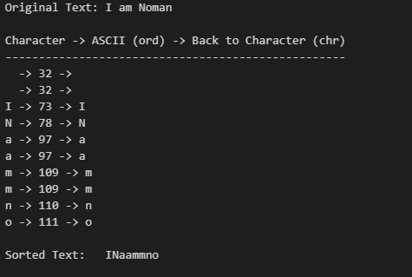

## 3) parse_sequence function

This function converts a sequence string into a list of integers.

It works for both formats: '5 8 9 3' (with spaces) or '5893' (continuous digits).

If digits have spaces, it splits them and converts each to integer.

If not, it reads each character and makes a list of numbers.

## 4) luhn_steps function (Luhn Algorithm check)

This function checks if a number sequence is valid using the Luhn Algorithm.

It separates the last digit as the check digit.

Then it reverses the other digits and doubles every second digit, adjusting values above 9.

Finally, it adds everything and checks if total % 10 == 0. If yes → the number is valid.

